MAVEN & SPRING CORE
Exercise 1: Configuring a Basic Spring Application
File structure :
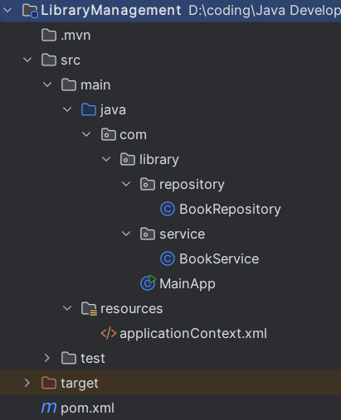

Pom.xml

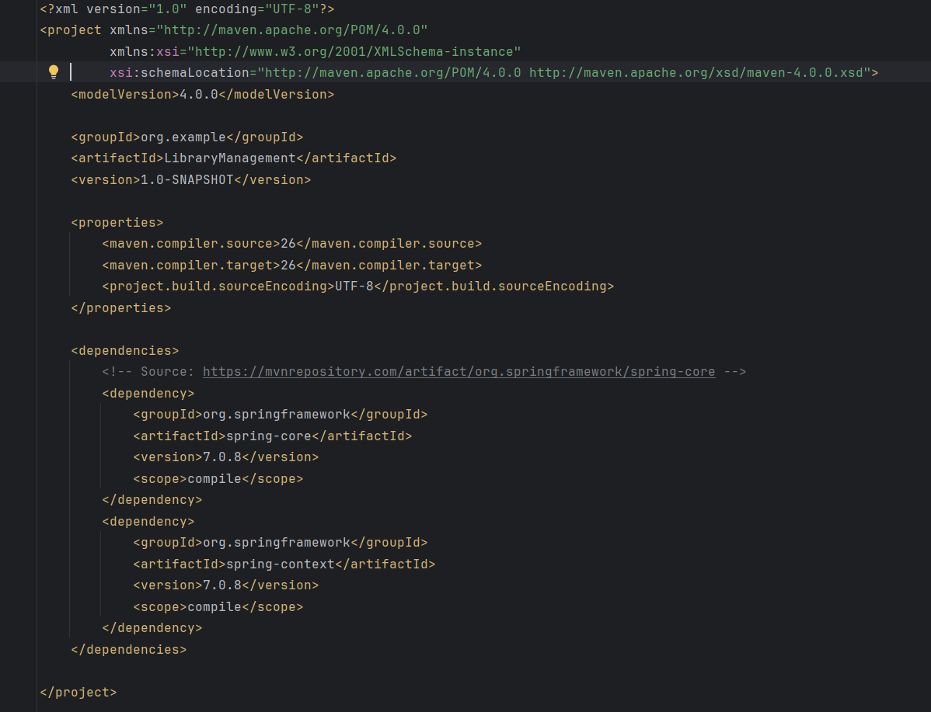

applicationContext.xml

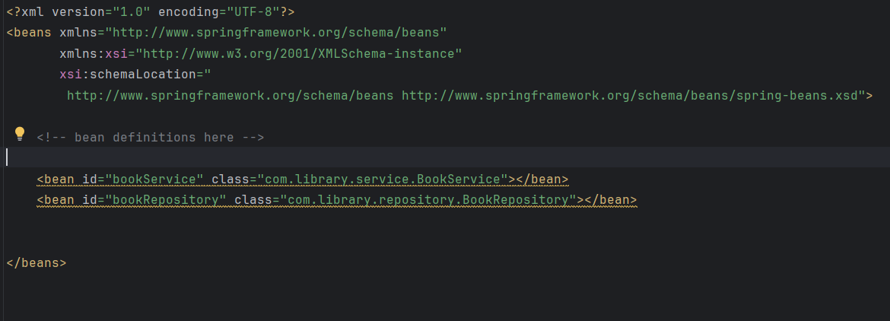

MainApp.java

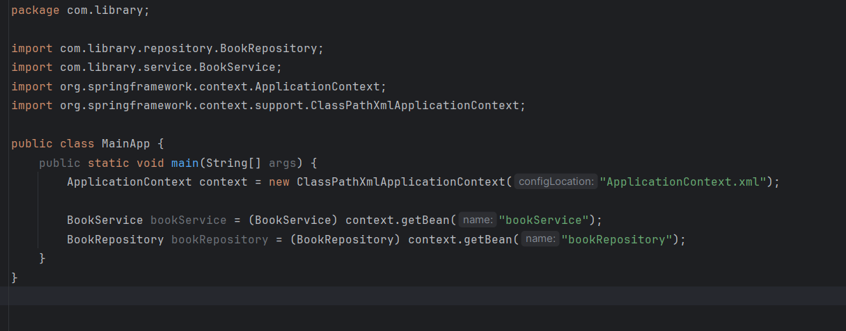

Exercise 2: Implementing Dependency Injection
wire BookRepository into BookService
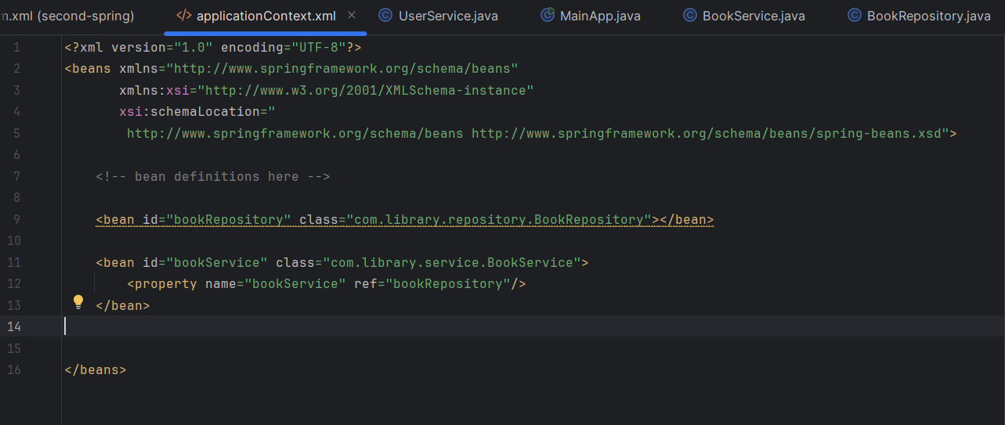

Setter method for dependency injection
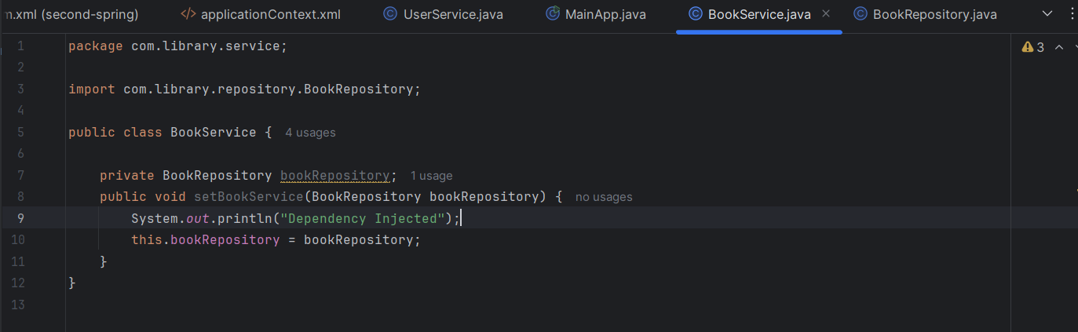

Output after running AppMain.java
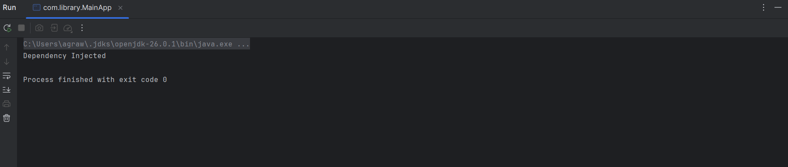

Exercise 4: Creating and Configuring a Maven Project
Include dependencies for Spring Context, Spring AOP, and Spring WebMVC
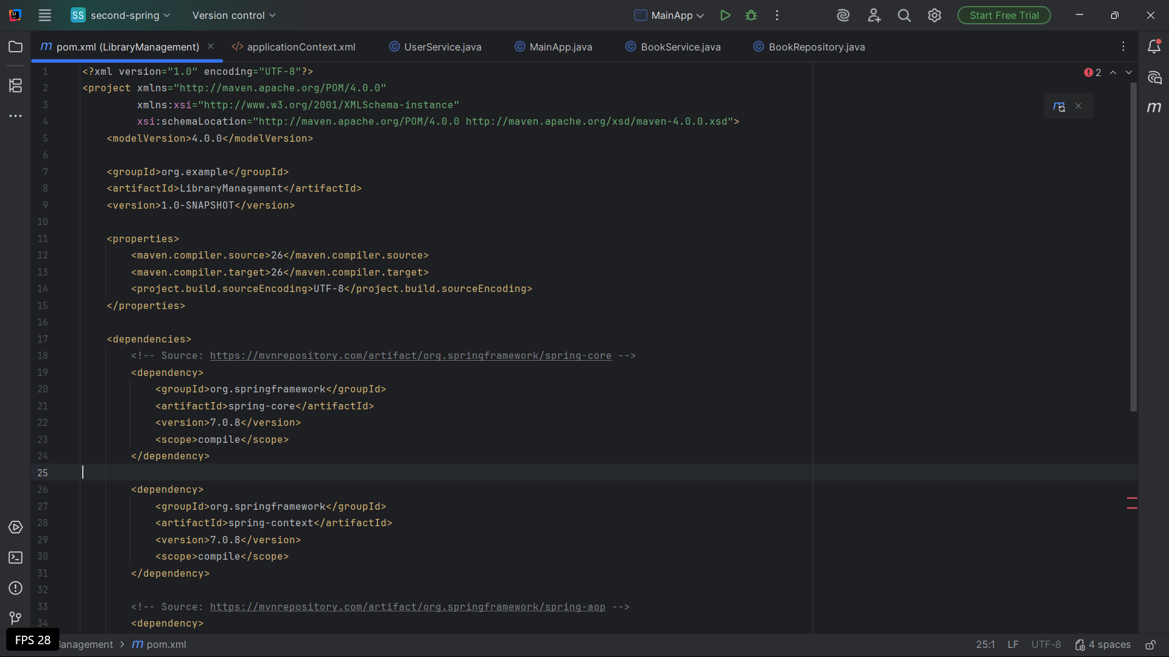

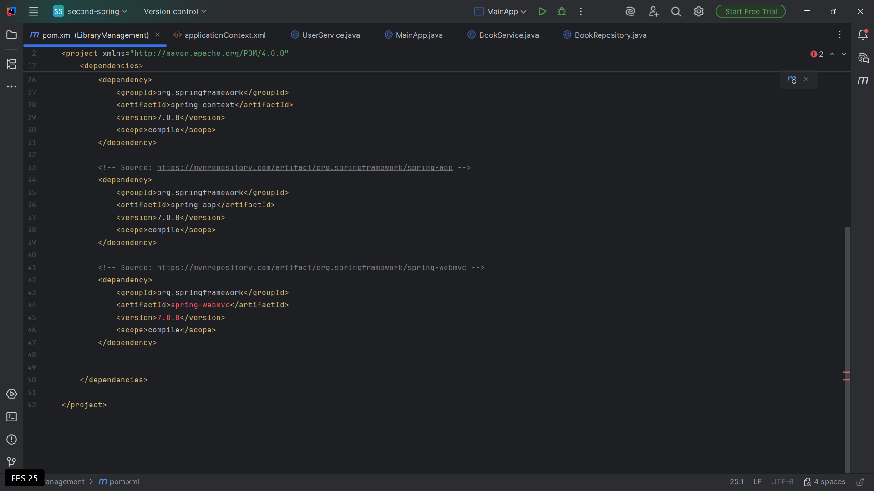

Configure the Maven Compiler Plugin for Java version 1.8 in the pom.xml file.
